**PROJECT 5 - DIGITAL LOGIC CIRCUITS**

**1. Your C, C++, or Python program, with comments.**

**Ans:**

**Python Program:**

import RPi.GPIO as GPIO #importing GPIO library

#Majority ckt pin number

mjbit0=17

mjbit1=27

mjbit2=22

#Minority ckt pin number

mnbit0=5

mnbit1=6

mnbit2=13

#Comparator ckt pin number

#First set

cfbit0=18

cfbit1=23

cfbit2=24

#Second set

csbit0=16

csbit1=20

csbit2=21

GPIO.setmode(GPIO.BCM)

GPIO.setup(mjbit0, GPIO.OUT)

GPIO.setup(mjbit1, GPIO.OUT)

GPIO.setup(mjbit2, GPIO.OUT)

GPIO.setup(mnbit0, GPIO.OUT)

GPIO.setup(mnbit1, GPIO.OUT)

GPIO.setup(mnbit2, GPIO.OUT)

GPIO.setup(cfbit0, GPIO.OUT)

GPIO.setup(cfbit1, GPIO.OUT)

GPIO.setup(cfbit2, GPIO.OUT)

GPIO.setup(csbit0, GPIO.OUT)

GPIO.setup(csbit1, GPIO.OUT)

GPIO.setup(csbit2, GPIO.OUT)

GPIO.output(mjbit0, 0)

GPIO.output(mjbit1, 0)

GPIO.output(mjbit2, 0)

GPIO.output(mnbit0, 0)

GPIO.output(mnbit1, 0)

GPIO.output(mnbit2, 0)

GPIO.output(cfbit0, 0)

GPIO.output(cfbit1, 0)

GPIO.output(cfbit2, 0)

GPIO.output(csbit0, 0)

GPIO.output(csbit1, 0)

GPIO.output(csbit2, 0)

def mjckt():

print("Majority function")

print("Enter value for bit 0 (0 or 1)")

mji1=input()

print("Enter value for bit 1 (0 or 1)")

mji2=input()

print("Enter value for bit 2 (0 or 1)")

mji3=input()

GPIO.output(mjbit0, int(mji1))

GPIO.output(mjbit1, int(mji2))

GPIO.output(mjbit2, int(mji3))

def mnckt():

print("Minority function")

print("Enter value for bit 0 (0 or 1)")

mni1=input()

print("Enter value for bit 1 (0 or 1)")

mni2=input()

print("Enter value for bit 2 (0 or 1)")

mni3=input()

GPIO.output(mnbit0, int(mni1))

GPIO.output(mnbit1, int(mni2))

GPIO.output(mnbit2, int(mni3))

def cckt():

print("Comparator function")

print("Enter values for first set")

print("Enter value for bit 0 (0 or 1)")

cfi1=input()

print("Enter value for bit 1 (0 or 1)")

cfi2=input()

print("Enter value for bit 2 (0 or 1)")

cfi3=input()

print("Enter values for second set")

print("Enter value for bit 0 (0 or 1)")

csi1=input()

print("Enter value for bit 1 (0 or 1)")

csi2=input()

print("Enter value for bit 2 (0 or 1)")

csi3=input()

GPIO.output(cfbit0, int(cfi1))

GPIO.output(cfbit1, int(cfi2))

GPIO.output(cfbit2, int(cfi3))

GPIO.output(csbit0, int(csi1))

GPIO.output(csbit1, int(csi2))

GPIO.output(csbit2, int(csi3))

while True:

print("********MENU*********")

print("\n")

print("1: Majority Function")

print("2: Minority Function")

print("3: Comparator Function")

print("q: Quit")

print("Enter your choice (1-3) or q:")

a = input()

if a=="1":

mjckt()

elif a=="2":

mnckt()

elif a=="3":

cckt()

elif a=="q":

print("Program Closed")

GPIO.cleanup()

exit()

else:

print("Invalid Entry")

print("Please Enter Again")

**2. Wiring diagram of your three LED circuits.**

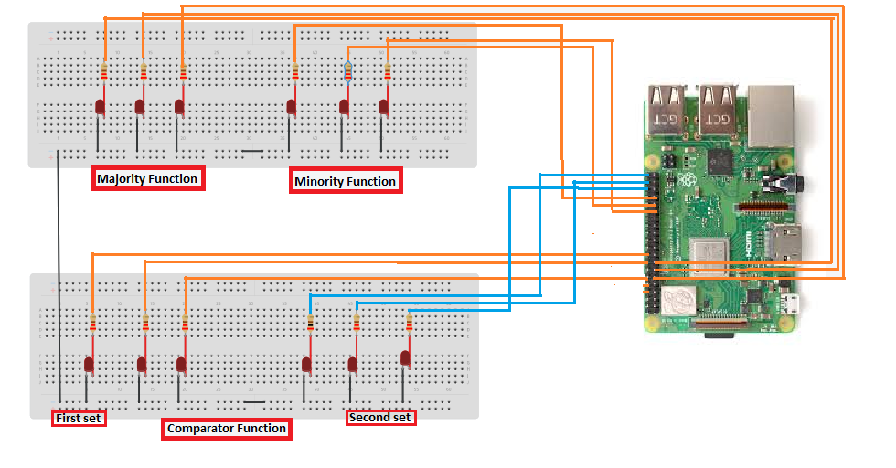**3. Picture of your three LED circuits.**

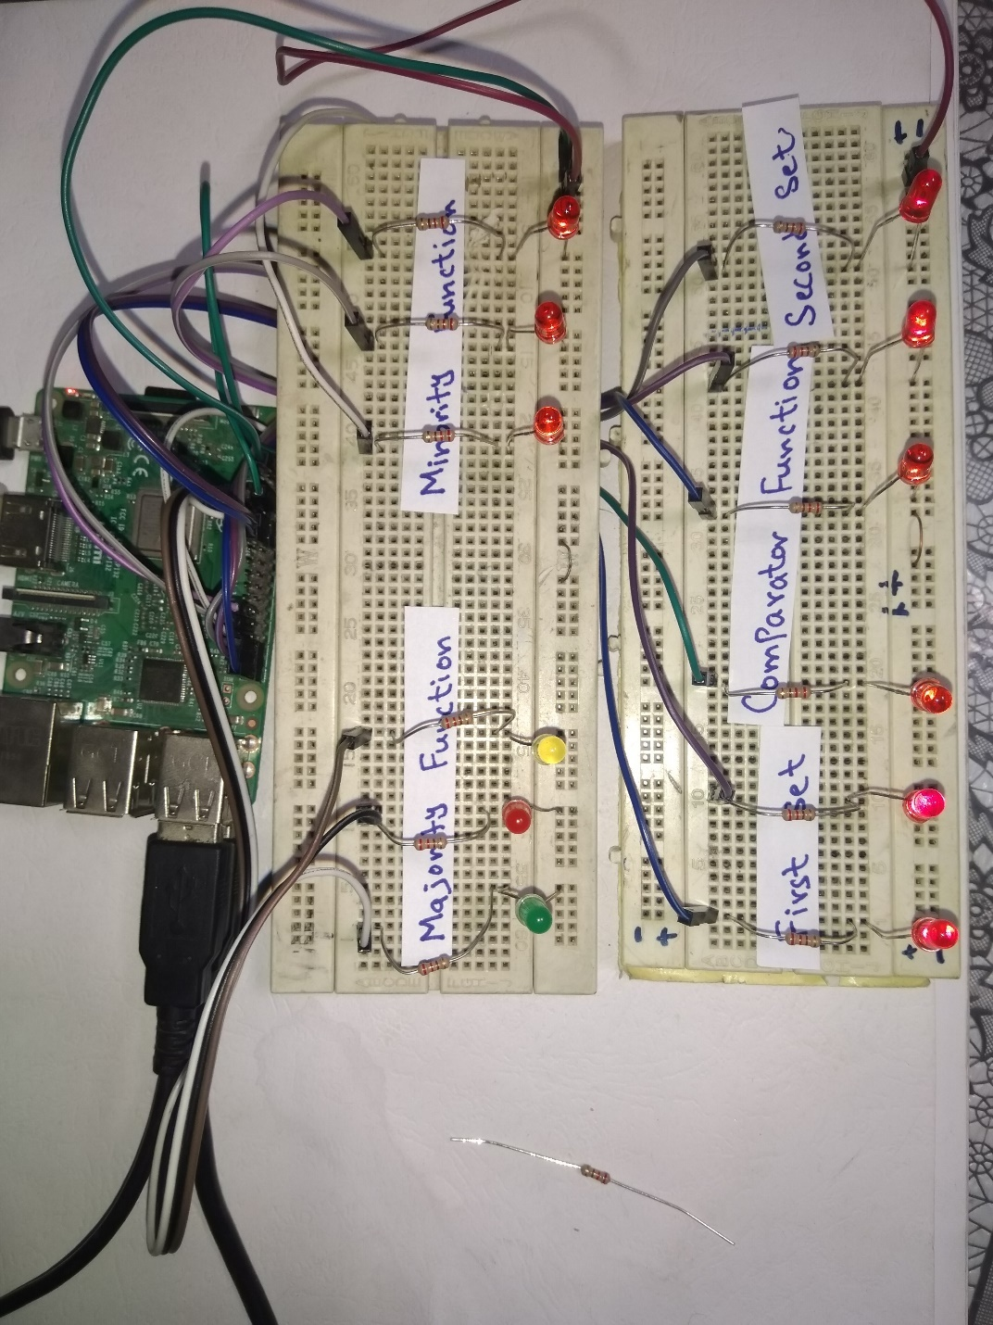

**4. Video demo of your project working with all menu options. A URL link to your video can be placed in the document. Make sure to set the permissions on your video file so that it can be viewed by anyone with the link.**

**Sol:**

[**https://youtu.be/Mdk6rO7SbyA**](https://youtu.be/Mdk6rO7SbyA)

**5. Describe your approach to this project. List any problems that you’ve encountered and how you overcame these issues.**

**Ans:**

In this project we have to show different function by using binary basics i.e. Majority function, Minority function & comparator function. The components used in this project are ready and 12 GPIO pins are used in this project. Attach the electronic circuit as shown in the above figure. Each Led is connected with the 220ohm resistor. The pulse to the LEDs is coming from the raspberry Pi GPIO pins. The GPIO pins use for majority functions are 17,27&22. For minority function the GPIO pin used are 5,6 & 13.and for comparator functions the GPIO pins used in two sets. First set GPIO pins: 18,23 & 24. Second set GPIO pins: 16,20 & 21.

After setting up the circuit, write python program to run this circuit. In python programming import all the required libraries that are essential to run this project. Firstly, define all the GPIO pins that are described above. Make all these GPIO pins as output. Initially these all GPIO pins are set at OFF state so all LEDS are OFF. We make this program to run infinite time till the user turn off the program by itself. The program can be closed by simply entering ‘q’ in the menu. In majority circuit the input taken by the program is three-bit ad further these three-bit input are used to turn on the pin output which at the end turn ON the LED. Like if a user enters two high state from total of three then GPIO pins corresponding to output are HIGH and show output. Similarly, in minority circuit if half of the input are in HIGH or LOW state represented by 1 or 0, then the output is corresponding to the input and turn ON the LEDs to show output. In comparator circuit, there are total 6 GPIO pins and LEDS connected. The program take input of both first and second set and make the output HIGH of the same input. Like if in both sets the user input is 111, then all the 6 LEDS are ON. Basically, comparator circuit compare the input for both sets. If the input is same for both set then it turns ON the led.

In making this project there is no problem encountered in making its hardware circuit because that is simple. Only connect LEDs with resistors and GPIO pins of the raspberry Pi. But in programming side I face some problems, like to run these different functions as independent cases. So, I learned about functions and how to make cases to solve this problem.